Nathaniel Valla

Computational Problems II

Lab 7 set up

Start up:

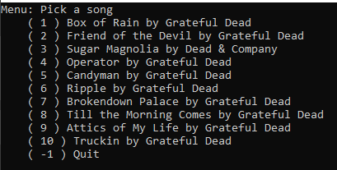

Pick a song

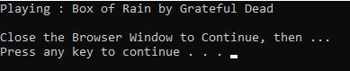

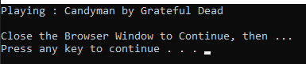

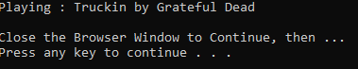

Pick not a song



Quit

